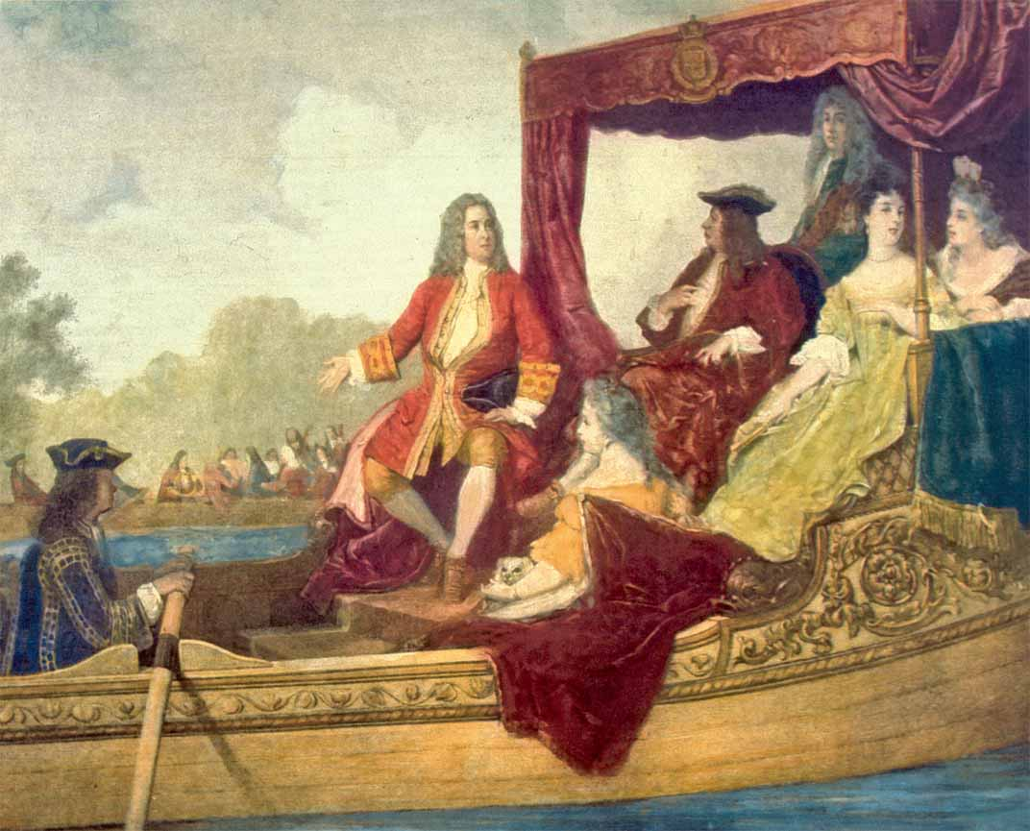

[George Frideric Handel](http://en.wikipedia.org/wiki/George_Frideric_Handel) and King George I on the Thames (“tims”) River in 1717. The 50 musicians on the other barge had to play all of *Water Music* three times because the King liked it so much.

Painting by Edouard Jean Conrad Hamman